Day 33 - 04th Sept 2025
Id- hrajranj

Task 01👍

What do you understand by DynamoDb Architecture.. ? explain using a diagram.
Amazon DynamoDB is a fully managed, serverless NoSQL database designed to provide high performance, scalability, and availability. Its architecture is based on distributed systems principles.
Key Components:
- Tables
  - Core container for data.
  - Data is stored as items (rows), and each item is made up of attributes (columns).
  - Each table must have a Primary Key:
    - Partition Key (hash key)
    - (Optional) Sort Key (range key)
- Partitions
  - Data is automatically split across multiple partitions based on the partition key.
  - Each partition is stored on SSD-backed storage for low-latency reads/writes.
- Data Distribution & Partitioning
  - DynamoDB uses consistent hashing to distribute data across partitions.
  - Ensures scalability by balancing load evenly.
- Replication & Availability
  - Data is synchronously replicated across multiple Availability Zones (AZs) in a region.
  - Provides high availability and fault tolerance.
- Storage & Write-Ahead Logs (WALs)
  - Every write is first written to a commit log for durability.
  - Then, data is replicated and indexed across partitions.
- Indexes
  - Global Secondary Index (GSI): Query on non-primary key attributes.
  - Local Secondary Index (LSI): Query on sort key variations within a partition.
- Request Router
  - When an application sends a request, DynamoDB routes it to the correct partition using the partition key’s hash value.
- Streams (Optional)
  - DynamoDB Streams capture changes (insert, update, delete) for real-time processing (e.g., with AWS Lambda).

🔹 DynamoDB Architecture Diagram
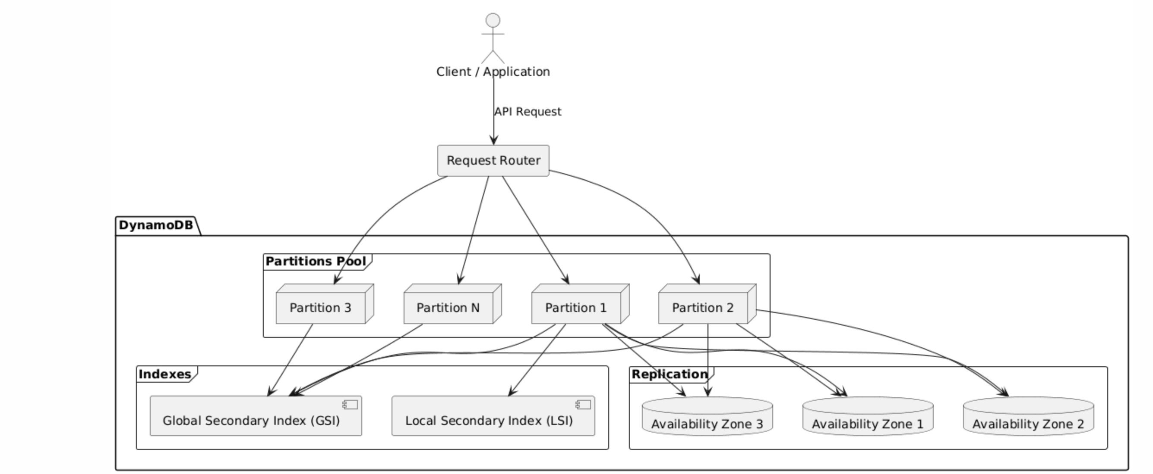
Indexes:
- Local Secondary Index (LSI) -> within same partition
- Global Secondary Index (GSI) -> across multiple partitions

Task 02:

What are multivalue sorts or filters..? Explain briefly..
DynamoDB doesn’t support multi-value sort keys directly (like ordering on multiple attributes at once, e.g., SQL’s ORDER BY col1, col2). Instead, it uses partition key + sort key to organize data, and you can apply filters when querying.
1. Sort Key (Single or Composite Behavior)
- In DynamoDB, every item in a table (with composite primary key) has:
  - Partition Key → Determines the partition where the item is stored.
  - Sort Key → Orders items within the same partition.
- You can query using conditions on the sort key, e.g.:
  - begins_with(sortKey, "2025-09") → Fetch all items in Sept 2025.
  - between("A", "Z") → Range queries.
👉 If you want multi-value sorting (like sorting by date and then by price), the common trick is to concatenate multiple fields into a single sort key, e.g.:
sortKey = "2025-09#1000"
So you can sort by date first, then price.

2. Filters
- A FilterExpression is applied after DynamoDB fetches matching items based on the primary key (partition + sort key).
- Example:
- Query: Get all orders for customerId=123 (partition key)
- Filter: status = "DELIVERED"
- The filter does not reduce read capacity consumed (since DynamoDB reads all items first, then filters client-side).
👉 Multi-value filters mean applying multiple conditions, e.g.:
FilterExpression: "status = :s AND price >= :p"
- You can also combine with IN to match multiple values:
FilterExpression: "category IN (:c1, :c2, :c3)"

✅ In summary:
- DynamoDB only natively sorts on one sort key per table/query.
- For multi-value sort, you must design a composite sort key (concatenated fields).
- For multi-value filtering, use FilterExpression with AND, OR, or IN.

Task 03:

How do you lower the cost of DynomaDB..explain ways to do so…

Here’s a breakdown of strategies to lower DynamoDB costs:

🔹 1. Choose the Right Capacity Mode
- On-Demand: Pay per request (good for unpredictable or low traffic).
- Provisioned with Auto Scaling: Set base capacity, auto-adjusts up/down → cheaper for steady or predictable workloads.
👉 Tip: If traffic is bursty but mostly low, On-Demand is better. If steady traffic, Provisioned is cheaper.

🔹 2. Optimize Data Access Patterns
- Design queries around partition & sort keys → fetch fewer items.
- Avoid Scan (reads the whole table) → expensive.
- Use Query instead → only fetch needed items.
- Use FilterExpression sparingly (filters don’t reduce read capacity, they discard after reading).

🔹 3. Use Smaller Item Sizes
- DynamoDB pricing is based on Read/Write Capacity Units (RCU/WCU) and data size.
- Minimize attributes stored in each item.
- Store large objects (images, docs, logs) in S3, and keep only references (URLs) in DynamoDB.

🔹 4. TTL (Time To Live)
- Enable Time to Live (TTL) on attributes to auto-delete old data.
- Helps reduce storage costs by cleaning up unused/expired records.

🔹 5. Optimize Index Usage
- Indexes (LSI, GSI) cost extra (storage + RCUs/WCUs).
- Only create GSIs that are really needed.
- Consider projecting fewer attributes into indexes (don’t project ALL_ATTRIBUTES unless necessary).

🔹 6. Use DAX (DynamoDB Accelerator) or Caching
- Add DAX or use AWS ElastiCache / CloudFront to cache frequently accessed items.
- Reduces the number of DynamoDB reads → lowers RCU cost.

🔹 7. Batch Operations
- Use BatchGetItem and BatchWriteItem instead of multiple single requests.
- More efficient → lowers API request cost.

🔹 8. Monitor & Optimize with CloudWatch + AWS Cost Explorer
- Track consumed vs. provisioned capacity.
- If consistently overprovisioned, scale down.
- If consistently underprovisioned, use On-Demand.

🔹 9. Use DynamoDB Streams Selectively
- Streams incur extra cost.
- Enable only for tables where you really need change tracking.

✅ Summary of Cost-Saving Tips:
- Pick On-Demand or Provisioned wisely.
- Use Query > Scan.
- Move large data to S3.
- Enable TTL.
- Optimize Indexes.
- Add caching.
- Use batch APIs.
- Monitor usage & adjust capacity.

